**TCP/IP Attacks SEED Lab**



**TCP/IP Attacks SEED Lab**

**Main Introduction:**

The vulnerabilities in the TCP/IP protocols represent a special genre of vulnerabilities in protocol designs and implementations; they provide an invaluable lesson as to why security should be designed in from the beginning, rather than being added as an afterthought.

In this lab, I will conduct the following attacks on TCP connection:

• TCP SYN flood attack

• TCP reset attack

• TCP session hijacking attack

• Reverse shell

**Network physical topology:**

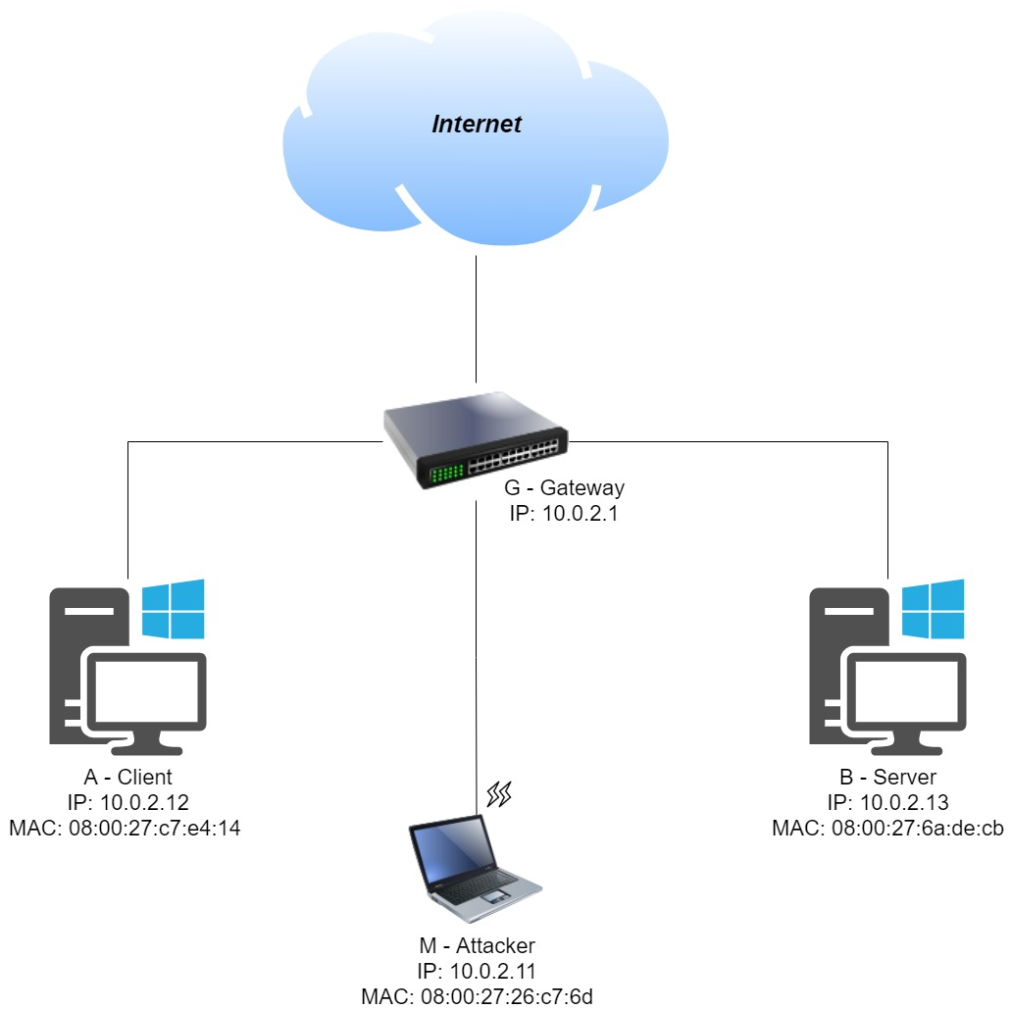

**Task 1: SYN Flooding Attack**

**Task Description:**

I will use the netwox tool to create SYN Flood attack on a server.

By sending a lot of SYN requests to a TCP port and not finishing the 3-way handshake, the attacker floods the victim’s queue.

I will shut off the SYN flood countermeasures on the victim to perform the attack.

By executing the commands on the server (10.0.2.13)

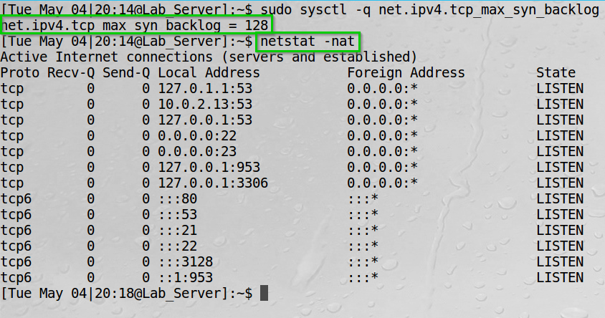“sudo sysctl -q net.ipv4.tcp_max_syn_backlog”  
“netstat -nat”  
I can check the victim’s queue size and the server connections.

The victim’s queue size is 128.   
We also see the current open ports that are on LISTEN state.   
If there’s only SYN received and not ACK from the client the stage is SYN_RECV.  
If the 3-way handshake procedure is completed, the state is ESTABLISHED.

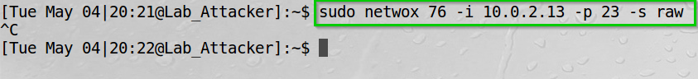On the Attacker (10.0.2.11) I launched the synflood attack using netwox.

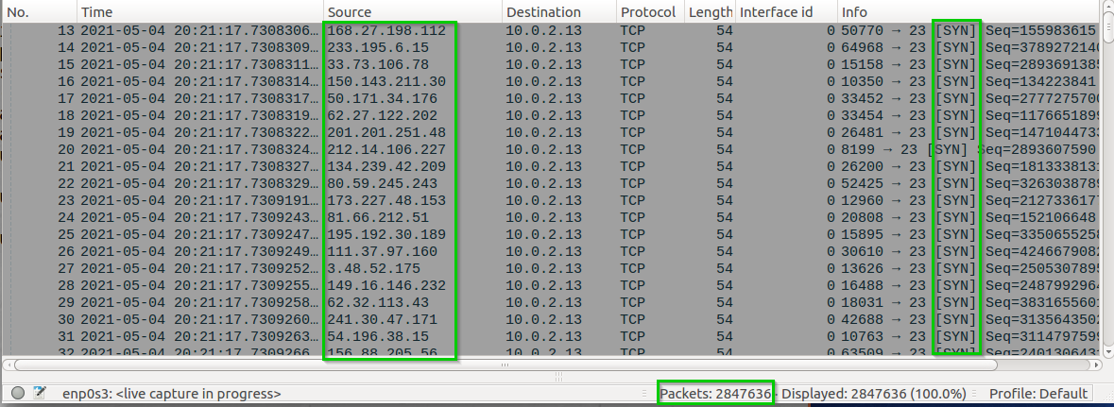On Wireshark we can see the SYN sent from the attacker machine

We can observe that netwox spoof the source IP and sent them all to 10.0.2.13.

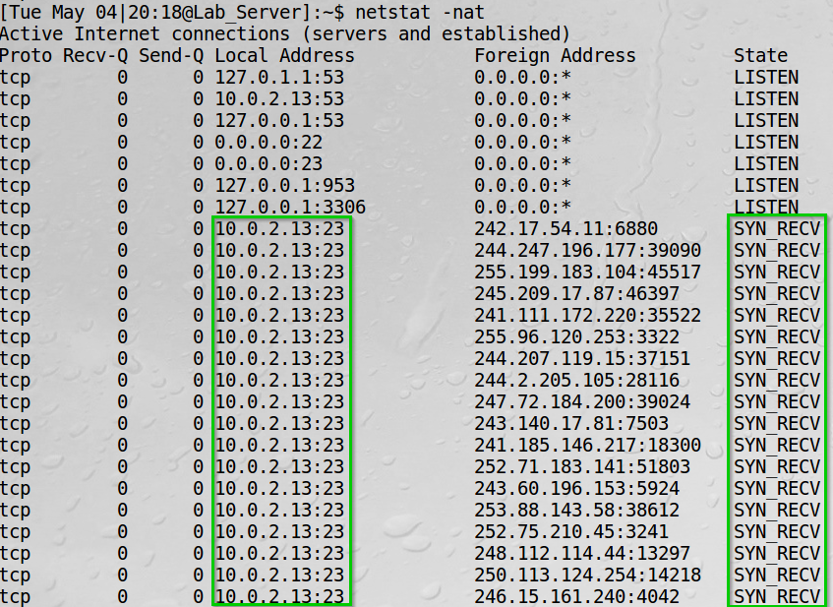We can see the network status on the server now.

We can see there are SYN_RECV state connections.

I then tried to open a telnet connection from the client (10.0.2.12) to the server (10.0.2.13).

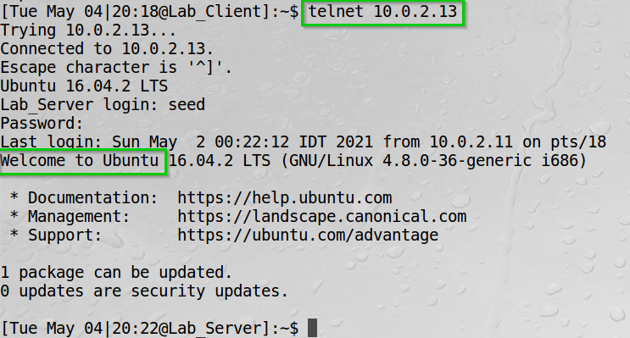We can see the connection is successful.  
The reason is that there are countermeasures to defend the server from a synflood attack (SYN Cookies).

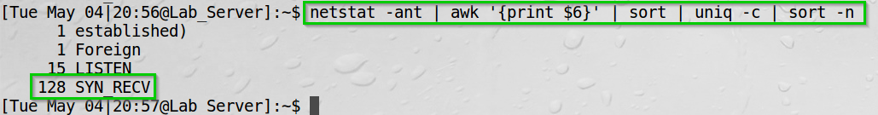We can see the netstat SYN_RECV count is 128.

The SYN cookie does not allocate resources when it receives the SYN packet, it allocates resources only if the server receives the final ACK packet. Thus prevents the synflood attack.

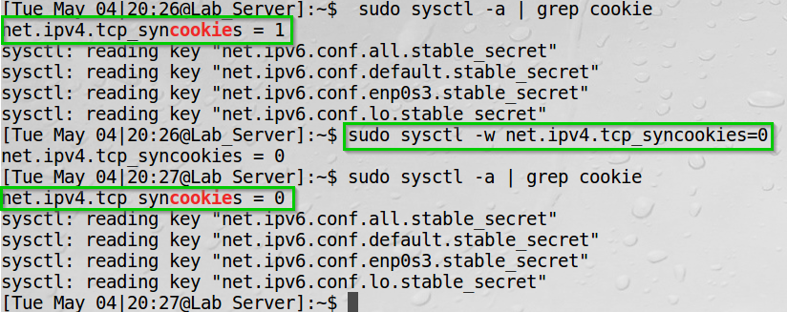I shut down the countermeasures.

We can see the tcp_syncookies is disabled.

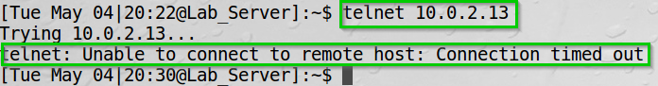After shutting down the countermeasure I launched the attack again and try to create a telnet connection again with the server.

We can observer however now that we cannot create the connection.

**Task 1 Summary**

* I have succeeded task. The screenshots, Wireshark and terminal output can show it.
* I started using the netwox tool to perform synflood attack on the server. Viewed the network statistics and Wireshark to see the SYN sent from the attacker and the SYN_RECV state on the server. I then successfully opened telnet connection from the client to the server.  
  Afterwards I shut down the SYN cookie mechanism and were able to perform the attack successfully.

**Task 2: TCP RST Attacks on telnet and SSH Connections**

**Task Description:**

I will launch TCP RST attack to terminate an established TCP connection between a telnet client and telnet server.  
I will do so by using both Netwox and Scapy.

**Breaking a Telnet connection:**

**Using Netwox:**

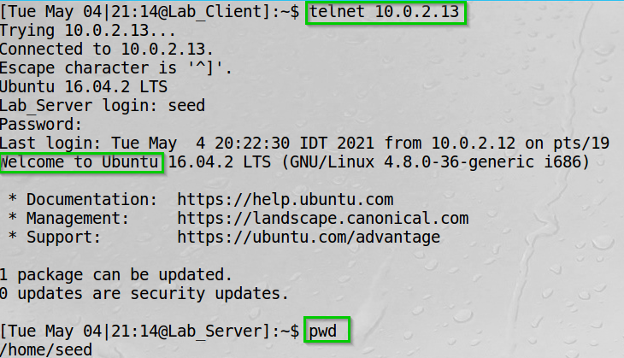I initiated a telnet connection from the client (10.0.2.12) to the server (10.0.2.13).

We can see the connection is successful and we also print the working directory on the server.

By using netstat, on the server (10.0.2.13), and filter the client IP address we can see any connection he has.

We can see the connection on port 23 (telnet) from the client (10.0.2.12) is established.

I then execute the netwox reset tcp attack.

We used the src host filter to reset any tcp connection from the client on port 23.

I also executed the netwox reset tcp attack with another filter for practice (not included in this report – however the behavior was the same)

**Note**: I filtered by the dst host and reset any connection on the server on port 23.

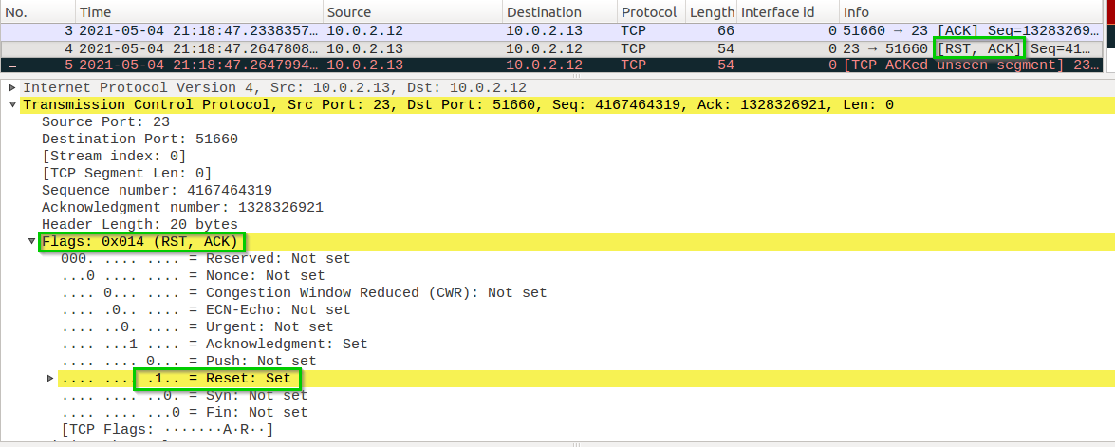By inspecting Wireshark, we can see the rst packet.

We can see the RST flag is set to 1.

We can see the connection broke.

**Using Scapy:**

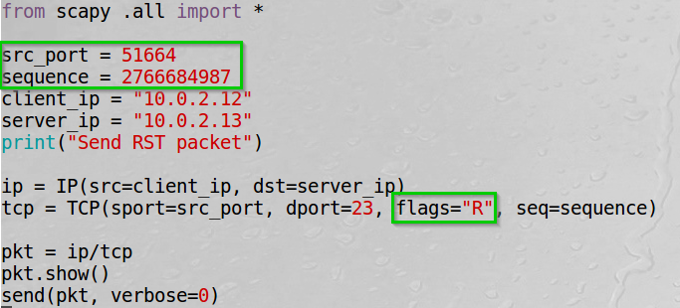I constructed the following code:

I set the src_port and sequence number by inspecting Wireshark and viewing the relevant information.

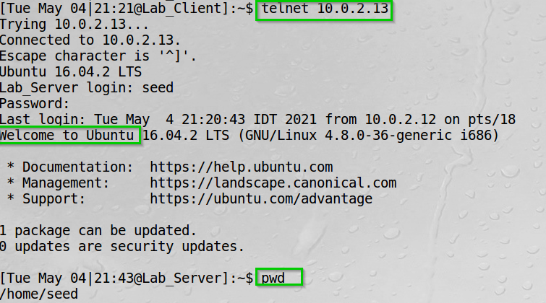I set up the telnet connection.

We can see a successful connection and the working directory on the server.

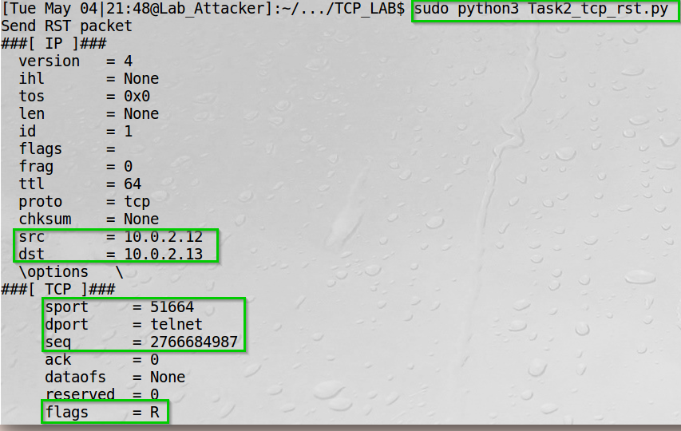I ran my script.

We can see the src dst addresses, the source port, sequence number and the Reset flag set.

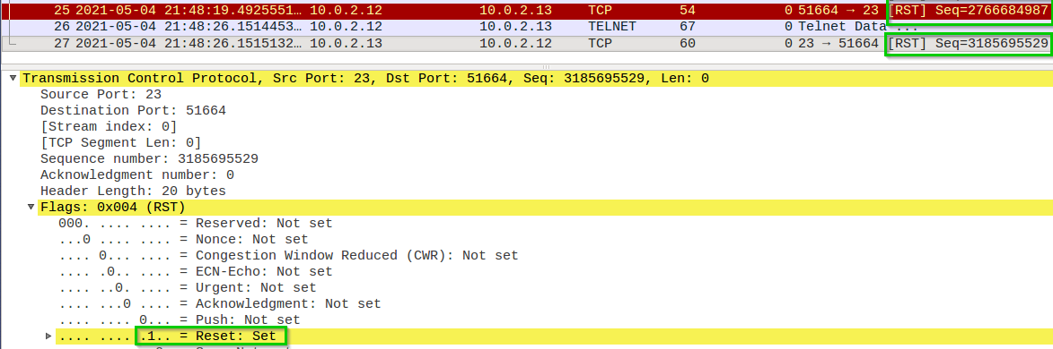 By inspecting Wireshark, we can see the rst packet.

We can see RST set to 1.

We can see the connection broke.  
**Note**: I forgot to take a snapshot, so I launched the attack again and took a snapshot – hence the time difference.

**Breaking an SSH connection:**

**Using Netwox:**

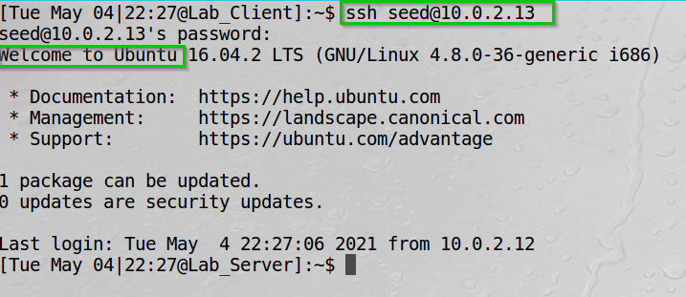I set up ssh connection from the client to the server.

We can see a successful connection.

On the server we can see the established connection as well.

We can see the connection between 10.0.2.12 and 0.0.2.13 on port 22.

I then executed the netwox 78 tool.

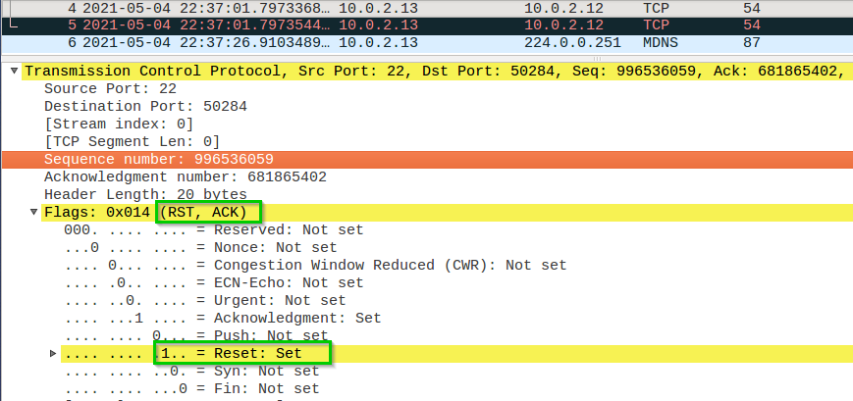On Wireshark we can see the rst packet.

We can see the rst flag set to 1.

Then we can see the connection break.

**Using Scapy:**

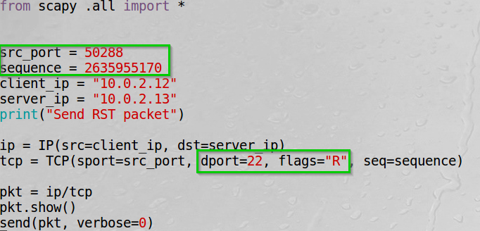I used the same rst attack as used for telnet.

Set the src_port , dst_port for ssh and set the Reset flag.  
Set the src_port and sequence number by inspecting Wireshark and viewing the relevant information.

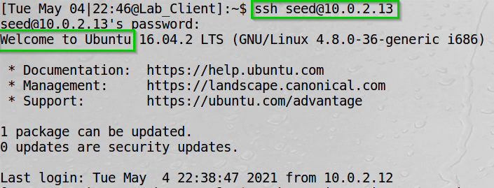Set up an SSH connection between the client and the server.

We can see a successful login.

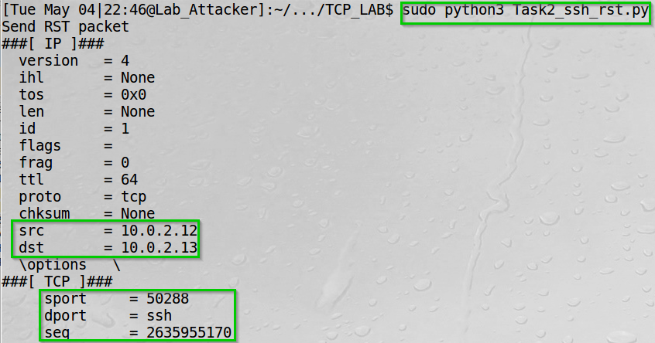I ran my script.

We can see the source and destination ip, the source and destination port and the sequence number.

Finally, we can see the ssh connection break.

**Task 2 Summary**

* I have succeeded task. The screenshots, Wireshark and terminal output can show it.
* I opened a connection between two parties (the client and the server), then also verified the connection looking at the netstat connections. I then started using the netwox tool to perform tcp reset attack on the server. I saw the SSH and telnet connection between the client and server break by using both netwox and my Scapy script.
* For my Scapy script I inspected Wireshark to find the connection source port and sequence number to succeed with the reset.

**Task 3: TCP RST Attacks on Video Streaming Applications**

**Task Description:**

I will launch TCP RST attack to terminate an established TCP connection between the victim (my own machine, the server 10.0.2.13) and the YouTube streaming video server.

**Network physical topology (For Task 3 Only):**

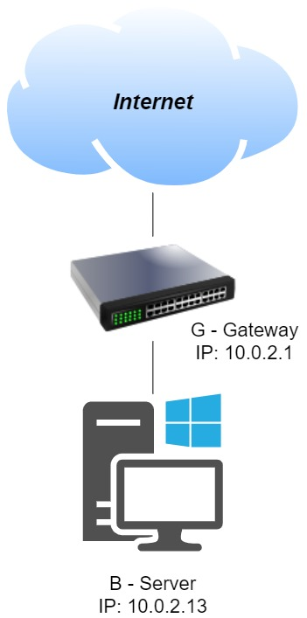

I used the Netwox tool in the next video.



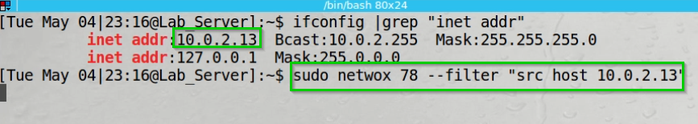Performed the attack on the same machine I streamed the video.

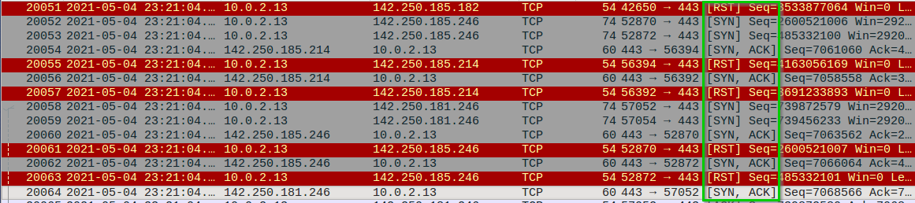I did notice somewhat of a slowing when performing the attack on YouTube. However, we see that when trying the attack on YouTube they do a very good job setting the connection back again and again.

We can see the connection keep it going on.

We can see a moment where the connection struggled.

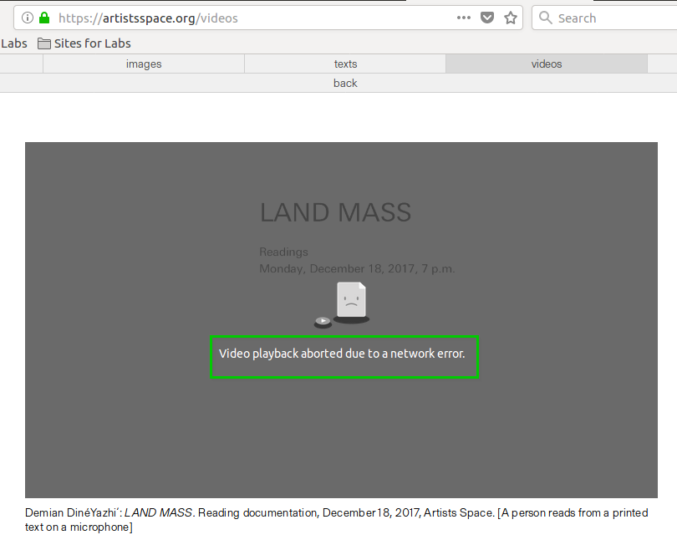I performed the attack on another website I found called artistsspace.org.

This time the attack was successful.

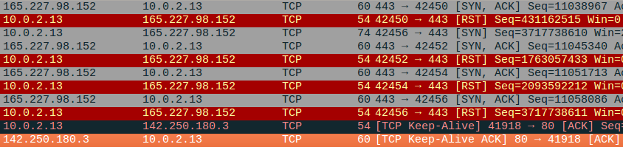On Wireshark.

I watched the traffic completely stop after the last   
TCP RST we can see in the screenshot.

**Task 3 Summary**

* I tried the attack on YouTube and artistsspace.org.
* I used the netwox tool to use tcp reset attack on my own host 10.0.2.13 and performed the attack.
* On YouTube I have seen somewhat of a slowdown however not as much as expected. By inspecting Wireshark, I understood YouTube set the connection again if it receives many tcp resets.
* On the artistsspace.org I have seen the connection completely break and the video has stopped streaming.

**Task 4: TCP Session Hijacking**

**Task Description:**

I will use the netwox tool and Scapy to hijack a telnet connection.   
I basically would check the Wireshark last tcp packet to get the sequence number and ack number so I could spoof packets and send them to the server and impersonate to be the client.   
I could send any command I want, and the server would execute it.

**Using Netwox:**

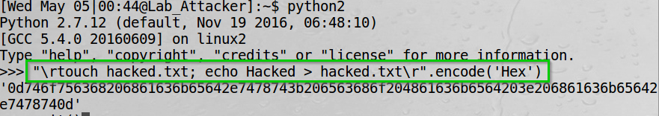Used python2 to encode the command I want to execute on the server.

We can see the hex output.

On the server I looked for the file containing the name “hacked”

We can see there was none.

Set up the telnet connection to the server.

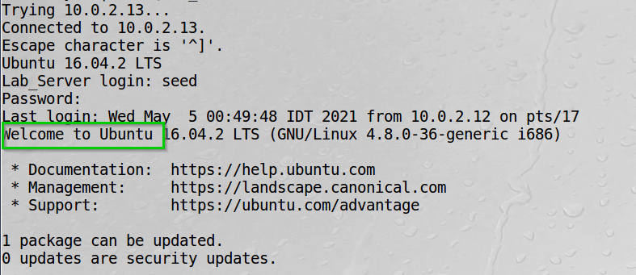

We can see a successful connection.

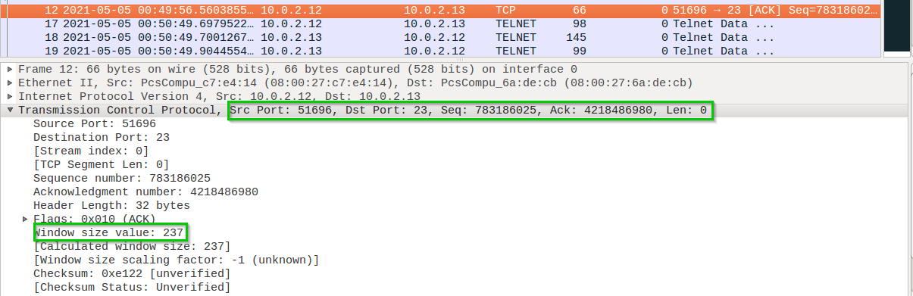On Wireshark we can see the last tcp packet sent.

We need this data to complete my netwox attack.

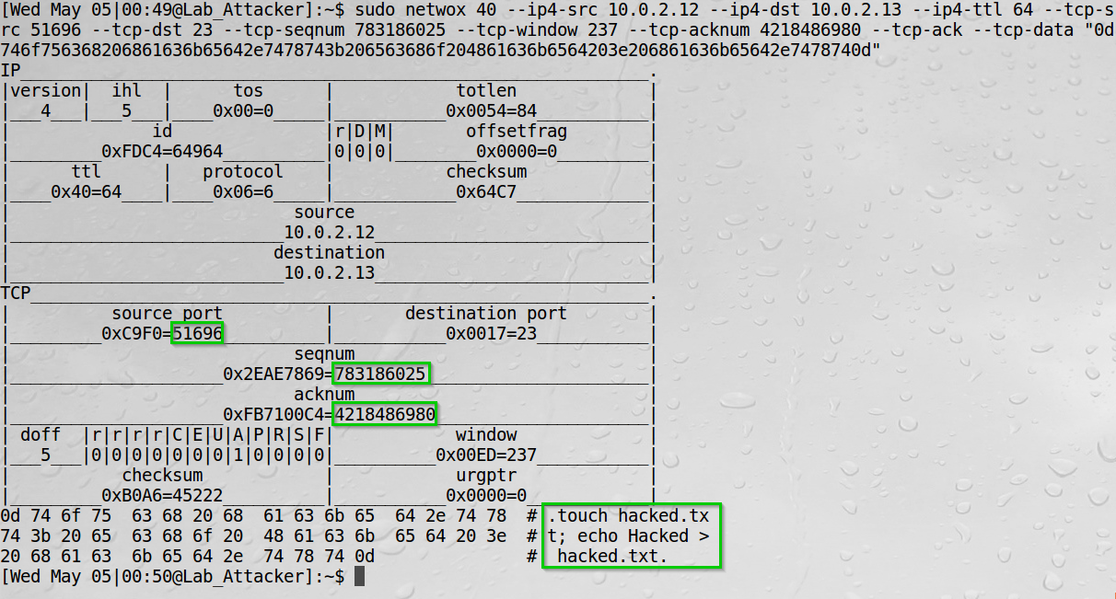I constructed the netwox attack parameters by viewing the tcp source, sequence number an ack number from the previous screenshot.

We can see the packet structure constructed by netwox and my command decoded to ASCII.

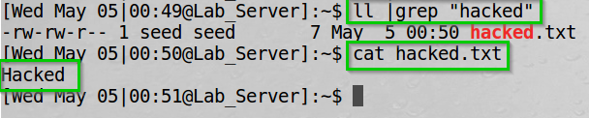On the server I checked again for the “hacked”.

We can now see the file created on the server, hence the attack worked.

**Observation:** on the client we can see the telnet is frozen now.   
The reason is that if we try to send more data from the client, it uses the sequence number the server already got so the server drops it.  
The client keeps resending the same data and frozen.

Also, the server sends back an ACK to the client, but the client did not send anything, so it drops it as well.

Of course, we can do much more damage than creating a harmless file. We could use “sudo rm -rf /” to delete the entire filesystem.

**Using Scapy:**

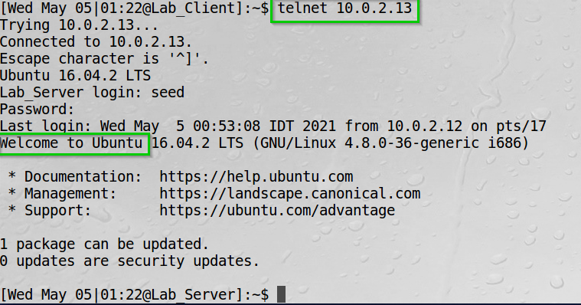I set up the telnet connection from the client to the server.

We can see a successful connection.

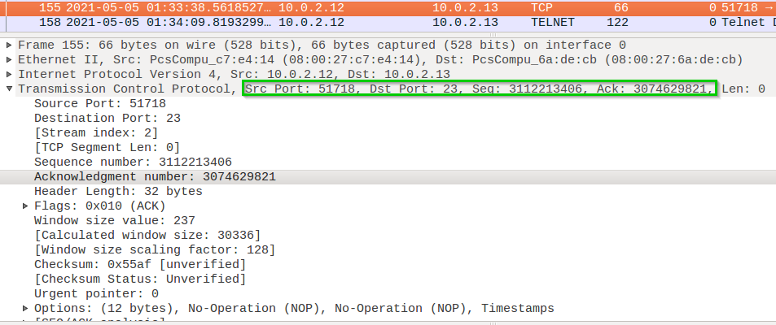We can see the last tcp packet on Wireshark.

We can see the source port, sequence number and acknowledgment number. We can use this information for my Scapy script.

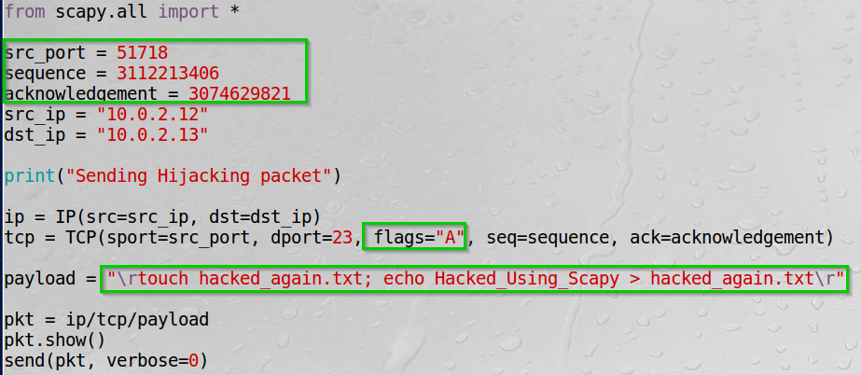I constructed the following packet.

We set the src port, seq number, ack number, flag A and the payload to create another file on the server.

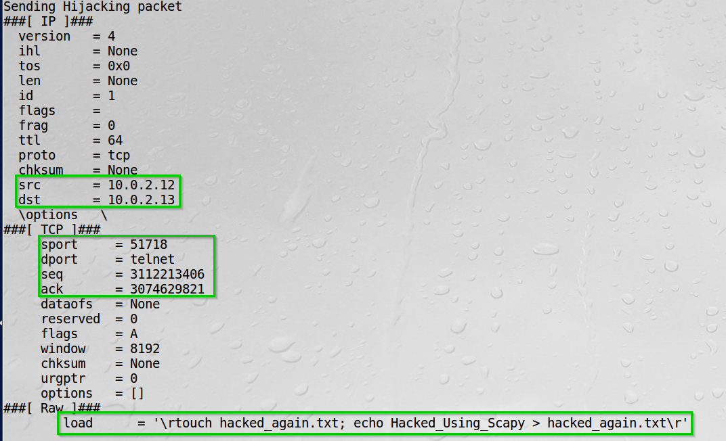Sent the packet from the attacker.

We can see the packet structure and the data we sent.

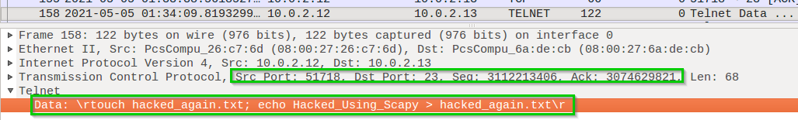By inspecting Wireshark, we can see packet.

We see the data we sent and the seq number, ack number.

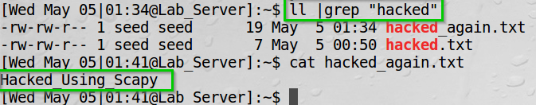On the server I looked for the file.

We see the file was created and its’ content.

**Task 4 Summary**

* I performed a session hijacking attack on telnet protocol.
* I used both Netwox and Scapy to construct a spoofed packet and sent is to the telnet server. I inspected Wireshark to find out the sequence number, acknowledgement number and source port from the last tcp packet found, then I used it and send the packets to the server and created a file on the /home/seed directory.
* I could have done way more – such as changing system files, changing FW rules, install packages remotely, deleting the server filesystem and destroy it completely.

**Task 5: Creating Reverse Shell using TCP Session Hijacking**

**Task description:**

I will perform tcp session hijacking using Scapy to create a reverse shell to my attacker.

I will open Netcat connection on the attacker, send a spoofed packet to the server instructing it to redirect the input/output of the shell to the connection between the server and the attacker,   
thus creating a backdoor.

I opened a Netcat connection on the attacker.

We can see the attacker listen on port 9090.

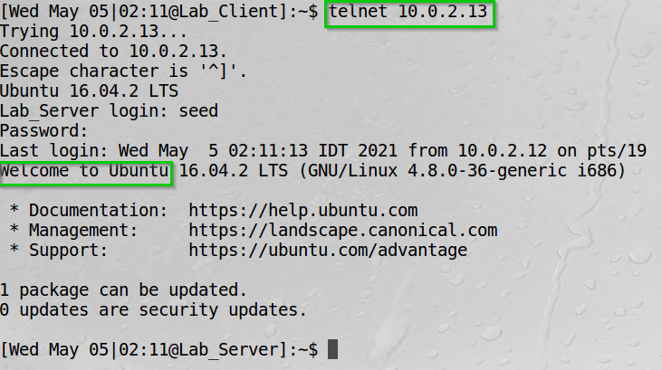Set up the telnet connection from the client to the server.

We can see a successful connection.

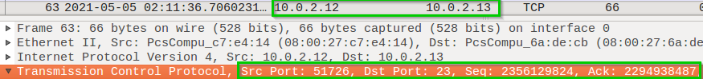I found the last tcp packet on Wireshark.

We can see the ip addresses, the source port, sequence number and ack number of the packet.

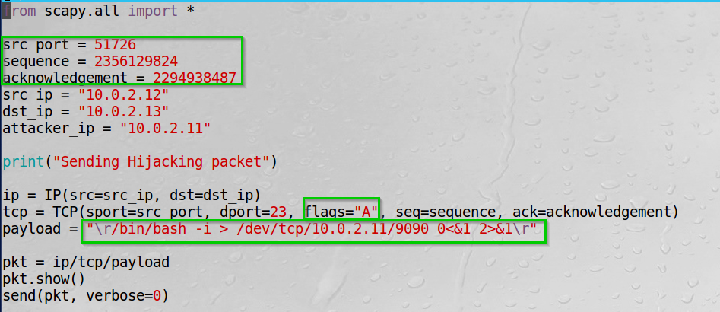Then I constructed the packet using Scapy with the information form the last screenshot.

We set the information and the payload:  
we want to open an interactive bash session.   
we instruct the server to use tcp connection to the attacker 10.0.2.11 on port 9090 as the standard output.   
Also set the standard input to be from the tcp connection and the standard error output as well.

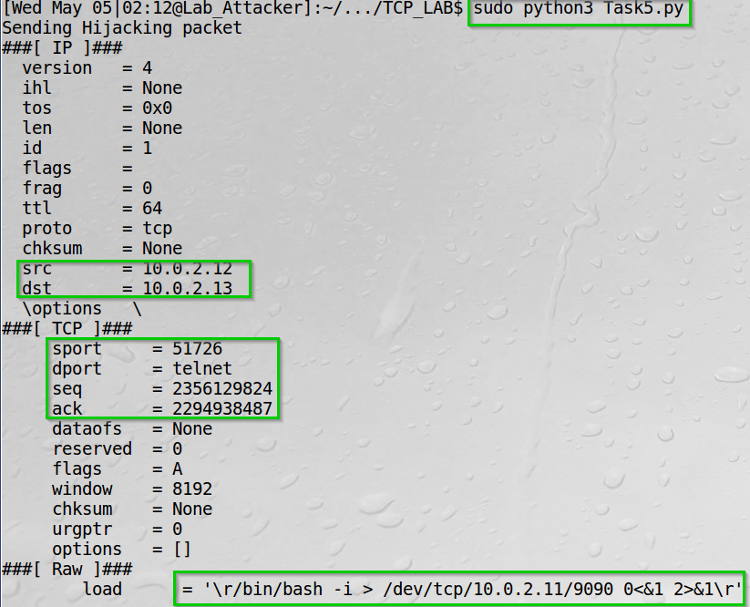I ran my script.

We can see the information we set and the command to the server.

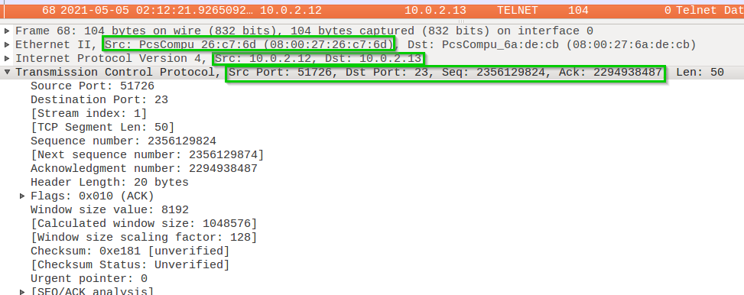On Wireshark we can see the packet we sent.

We can see the src and dst ip are the client’s and the server’s. The mac address belongs to the attacker. We can see the information we set on our script.

On the server we check the netstat, filtering our attacker ip 10.0.2.11.

We can see we have an established connection on with the attacker.

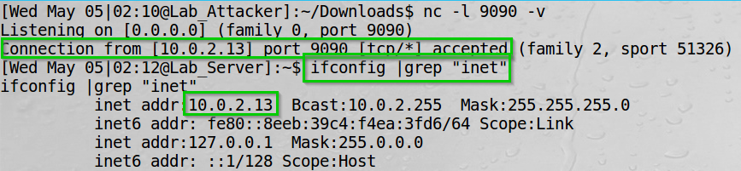We can now execute as many commands as we would like, by using our backdoor.

We can see the connection works. We check the ip address and can see we are indeed executing commands on the server.

**Task 5 Summary**

* I performed a session hijacking attack on telnet protocol.
* I set a telnet connection between the client and server, then constructed a packet on Scapy.
* The packet payload gained us a Netcat connection to the server, thus we can execute commands if the connection stays open.

**Lab Summary**

**Task 1:** I performed SYN flood attack using the Netwox tool, causing the server to not respond to SYN requests.

I had to turn off the SYN Cookie countermeasures to do so.

**Task 2:** I used both Netwox and Scapy to send TCP RST packets to break telnet and ssh connections between 2 machines.

Using Wireshark, I found out the connection’s information: ack number, sequence number, source port.

**Task 3:** I used Netwox to launch TCP RST attack to break a connection on video streaming connection.

I used the Netwox filter on the server host itself.

I have succeeded breaking the connection on artistsspace.org and watched the video stuck.

On YouTube I failed breaking the connection. however, did notice a slightly bumpy connection.

**Task 4:** I Used both Netwox and Scapy perform TCP Session Hijacking.

Initiated a telnet connection between the client and server, then found the sequence number, ack number and src port on Wireshark and used it to construct a packet using both Netwox and Scapy.

I have launched the attack and managed to create a file on the server using the client connection’s information to the server.

I did see the client’s connection froze – since both the client and server are now outdated as for the sequence and ack number they should be receiving, causing them send and wait for a packet that would never arrive.

**Task 5:** I used Scapy to create Reverse Shell using TCP Session Hijacking.

Started a Netcat connection on the attacker listening on port 9090.

Performed the same attack as in task 4 but I changed the payload to execute a command instructing the server to set the stdout to the tcp connection to the attacker on port 9090. Also, the stdin and stderr are redirected to the tcp connection.

Thus, giving me the ability to execute commands on the server through a backdoor.

**Innovation**

**TCP Attacks Mitigation:**

**Micro blocks**—administrators can allocate a micro-record (as few as 16 bytes) in the server memory for each incoming SYN request instead of a complete connection object.

**SYN cookies**—using cryptographic hashing, the server sends its SYN-ACK response with a sequence number (seqno) that is constructed from the client IP address, port number, and possibly other unique identifying information. When the client responds, this hash is included in the ACK packet. The server verifies the ACK, and only then allocates memory for the connection.

**RST cookies**—for the first request from a given client, the server intentionally sends an invalid SYN-ACK. This should result in the client generating an RST packet, which tells the server something is wrong. If this is received, the server knows the request is legitimate, logs the client, and accepts subsequent incoming connections from it.

**Session Hijacking Mitigation:**

End-to-end encryption between the two parties, vpn.